Mark 9:1-13
The Transfiguration
Chris Tyack

9.1 Not taste death until (heos) Some are unsettled by v.9.1 since, according to conventional wisdom, we are still waiting for the kingdom!
Dennis Nineham says: “The difficulty that has been felt about this interpretation is that it makes our Lord foreshorten the perspective drastically as sets very [231] definite bounds to the extent of his accurate foreknowledge in the days of his flesh. Nevertheless, especially in view of such a passage as Matt 10:23, and of the expectations of the early Church (cf. e.g. 1 Cor 7:29 and 31, 10:11, Rom 13:11, etc), the interpretation is to be accepted, and numerous writers have shown that admission of such ignorance, and even error, on the part of our Lord is fully compatible with belief in the Incarnation.” 232
Yet, we may understand that the coming of the reign is shortly to be seen in the Transfiguration. Nineham dismisses such an interpretation: “However we interpret what the disciples saw, it could scarcely, in reality, have been called the kingdom of God come with power.” (236) Yet the better reading is surely that the basileia, the reign of God is not a sudden world-transformation, so much as a hidden dimension of reality, perceptible only by them “with eyes to see.”
Six days later That is, on the seventh day - the Sabbath day.
Nineham notes that “…there is some evidence that this was traditionally the length of time required for preparation and self-purification before a close approach to God (cf. eg. Exod. 24:16…)” (234)
I suggest that that “six days later” is a pointed allusion to Exodus 24: just as God calls to Moses from the cloud on Mt Sinai upon the Sabbath day, so God’s voice is heard on the mountain.
The episode in Exodus is about the sealing of the Mosaic covenant—the writing of the law on tablets. The initial approach to the mountain is on the Sabbath day:
9 Then Moses and Aaron, Nadab, and Abihu, and seventy of the elders of Israel went up, 10 and they saw the God of Israel. Under his feet there was something like a pavement of sapphire stone, like the very heaven for clearness. 11 God[a] did not lay his hand on the chief men of the people of Israel; also they beheld God, and they ate and drank.
12 The Lord said to Moses, “Come up to me on the mountain, and wait there; and I will give you the tablets of stone, with the law and the commandment, which I have written for their instruction.”
Moses goes still higher. After six days—i.e. on the seventh, the Sabbath—God calls to him:
“5 Then Moses went up on the mountain, and the cloud covered the mountain. 16 The glory of the Lord settled on Mount Sinai, and the cloud covered it for six days; on the seventh day he called to Moses out of the cloud. 17 Now the appearance of the glory of the Lord was like a devouring fire on the top of the mountain in the sight of the people of Israel. 18 Moses entered the cloud, and went up on the mountain. Moses was on the mountain for forty days and forty nights.”
What God there reveals to Moses is the pattern of the Tent of Meeting—including the Ark, the Bread of the Presence, the Lampstand (Menora), and the altar for burnt offerings.
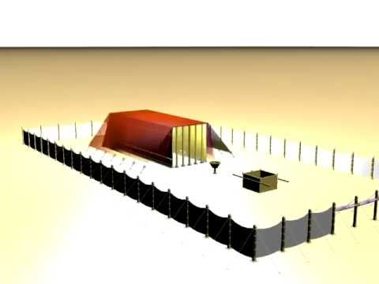
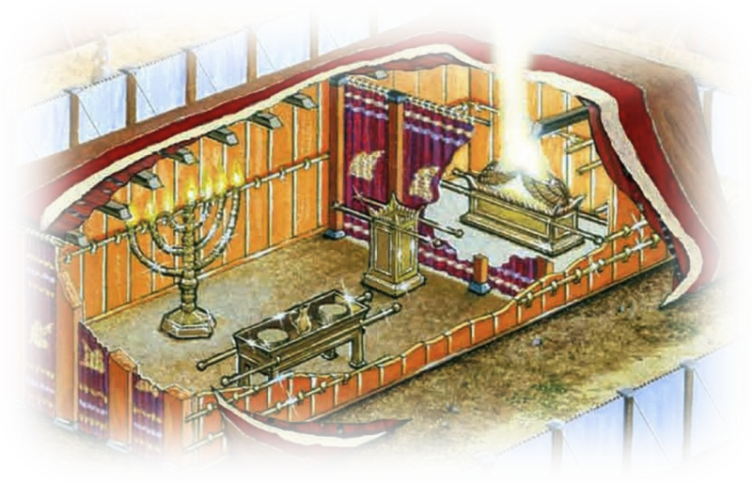
The Tent of Meeting symbolises God’s covenant with Moses in the desert.
He changed his appearance (metamophothe). It appears to be significant that Jesus did not change his substance but only his appearance—and that to particular disciples. This is accords with the Platonic, and probably more widespread ancient view that things do not have an objective reality in the world—but are rather appearances. Reality is not straightforward but is always mediated by the mind and the senses (c.f. Plato’s Thaetaetus, on epistemology.)
Origen, a Platonist, can therefore say: “…that, when seen, [Jesus] did not appear in like fashion to all those who saw Him, but according to their several ability to receive Him, will be clear to those who notice why … He did not admit all His apostles, but only Peter, and James, and John, because they alone were capable of beholding His glory on that occasion, and of observing the glorified appearance of Moses and Elijah, and of listening to their conversation, and to the voice from the heavenly cloud.”
Jesus’ garments shine dazzling white, such as no washer could wash them This may be an allusion to Malachi 3:2 “But who may abide the day of his coming? and who shall stand when he appears? for he is like a refiner's fire, and like fullers' soap”. That would be especially significant, for Mal 3:1 says “Behold, I will send my messenger, and he shall prepare the way before me: and the Lord, whom you seek, shall suddenly come to his temple, even the messenger of the covenant, whom you delight in”.
That implies that the Temple is not in Jerusalem, but in all the world—and focally on the mountain-top. It is a theme we found earlier in the feedings. It would explain, too, what commentators have not been able to explain: Jesus’ failure to enter triumphantly into the Temple on his arrival to Jerusalem. Instead, he turns around and goes home!
Moses and Elijah Traditionally taken to represent the law and the prophets. Malachi ch. 4 says: “Remember the Law of Moses My servant, the statutes and ordinances I commanded him for all Israel at Horeb. Behold, I will send you Elijah the prophet before the coming of the great and dreadful Day of the LORD.”
With Moses and Elijah, Jesus reigns as the Son of Humanity—the Human One, in the glory of the Father (cf. a possible allusion later in Mk 10:40)
Let us make three tabernacles The inappropriateness of Peter’s remark is not well understood. A tent is a symbol of the Mosaic covenant: yet Jesus announces a new covenant.
In the new covenant, the Temple is not made with hands—and into that Temple Jesus has suddenly come. It is a reference perceived only by the Venerable Bede: “Now because Peter sought for a material tabernacle, he was covered with the shadow of the cloud, that he might learn that in the resurrection they are to be protected not by the covering of houses, but by the glory of the Holy Ghost.”
My Son, the Beloved The Son of Humanity (Daniel 7) is also “the Beloved,” – my servant, in whom I delight of Isaiah 42. He is the Chosen One, in whom only there is election.

